ITTF PTTD

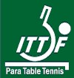
Technical Delegate report

Name of Tournament / Championships: Palma Slovak Open 2015
________________________________

Ranking Factor Applied for: 40

_________________________________

Name of Responsible Federation: Slovak Sports Organization for
the Disabled. Slovak PC + Slovak TT Association
_________________________________
Name of Chairman of Organising |  | Jan Riapos
Committee:
__________________________

Dates of Play:  __________________________ |  |  | May 12st – 17t^{h} , 2015
Name of Technical Delegate :  Deputy Technical Delegate:  ____________________ |  |  | James (JIM) Kenny (ENG)  Francesco NUZZO (ITA)
Report submitted to ITTF PTT :

Accommodation: OC used for the participants and officials three very good hotels: Double Tree by Hilton, 4*, Hotel Lindner 4*and Hotel Set.
Meals: |  | Breakfast and dinner were served in both of the hotels in the very good quality. Lunches were served for all of the participants in the hotel Double Tree by Hilton  (as it was closer to the Venue), and was very good in quality.
Transport: |  | The transports from the Airport Vienna – Schwechat and from the Airport Bratislava to the hotels were organized well, without any problems. Transport was also organised by the Slovenian organisation to get players from Slovenian open to Bratislava due to the tournaments being so close together.
 |  | The regular shuttle was organized only between the hotel Lindner and Venue, transport from the hotel Double Tree by Hilton was only 300 meters to the playing hall so was not required.
Venues : Venue was Andrej Nepela Ice Arena
A modern Ice Hockey stadium with 22 tables in the centre.

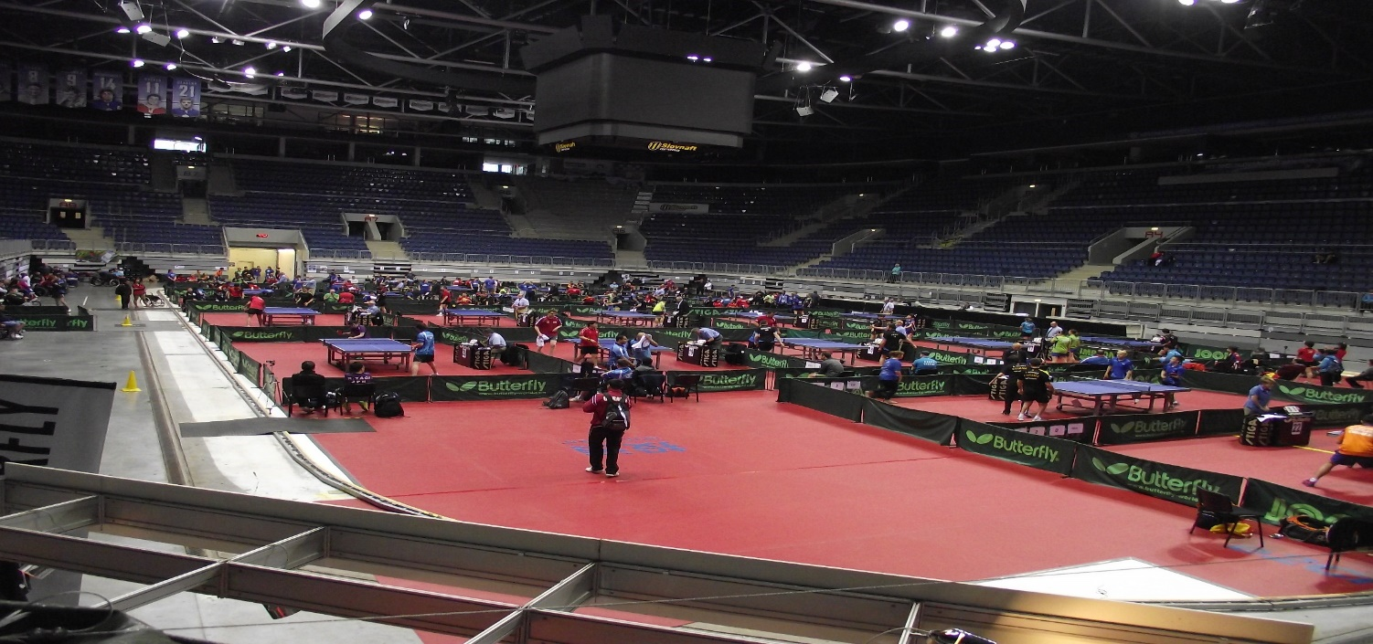
PLAYING HALL –

Number of tables:
22 Butterfly blue, ITTF approved, and all accessible for wheelchairs
Balls: DHS plastic balls
Floor: Taraflex (Red)
Lights: excellent, 1000 – 1200 Lux, without day light
Umpire tables: Butterfly, ITTF approved
Net/Post : Butterfly, ITTF approved
Surrounds: Butterfly ,ITTF approved
Towel boxes: Butterfly, ITTF approved
Referees table: In the middle of the longer side of the playing hall.
Computer men: By the referee table
Other rooms needed: OC + VIP room, TD room, Referee room, 2 rooms of Umpires, First aid room, 2 ball boys/girls rooms, call
Place for the Racket control

PRACTICE HALL –
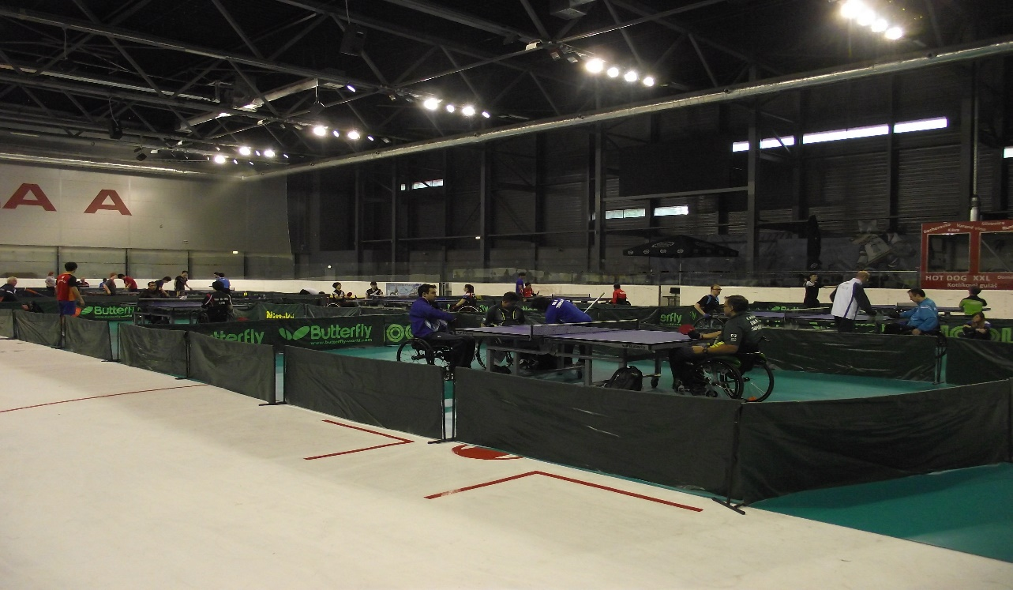

Number of tables : 8 practice tables - Butterfly blue, ITTF approved
Floor: taraflex
Light : good for the practice, between 600 - 700 Lux
Accessible toilets : in the Venue were 8 toilets accessible for the wheelchairs
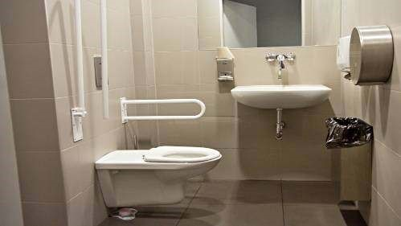 One of the wheelchairs accessible toilets.

Competition days: 12th May, 2015 Arrival day, draw of singles in classes and Technical meeting
13th May, 2015 Start of Single in classes
14thMay, 2015 Ending of Single in classes, Medals ceremony, start of Teams
15th May, 2015 Teams the whole day
16th May, 2015 Finish of Teams + Presentation ceremony and big Farewell party in Hotel Hilton, with entertainment.
17th May, 2013 Departure of the delegations, after the breakfast,

Participants : Present nations: 41

Officials : Technical Deleg.: James Kenny (ENG)
Referee: Elio Corrado ( ITA)
Deputy referee: Katja Brand (SUI)
Racket control : Marian Bystričan SVK

Ball boys: |  | Every day were present in the playing hall approximately 40 ball boys /girls
 |  | morning and the next 40 of them afternoon with their organizers.
Meetings : |  | A technical meeting was hold on May 12th , at 9 pm in the meeting room of

the hotel Hilton. The Organizers gave there to managers all of the needed information about the tournament + draw and time schedule for the Single in Classes.

Classification: In Fa 40 tournaments are not classifications, only one approved classifier observed players during the tournament.

Results : The running results were on the special inform desk, on the main playing hall. The Referee sent the final results immediately after the Single in Classes and next after the end of the Team´s events to ITTF PTT and Slovak Open webs and during the Farewell Party got every Delegations and the Officials CD ROM with the results, next information and very good pictures from the whole tournament.

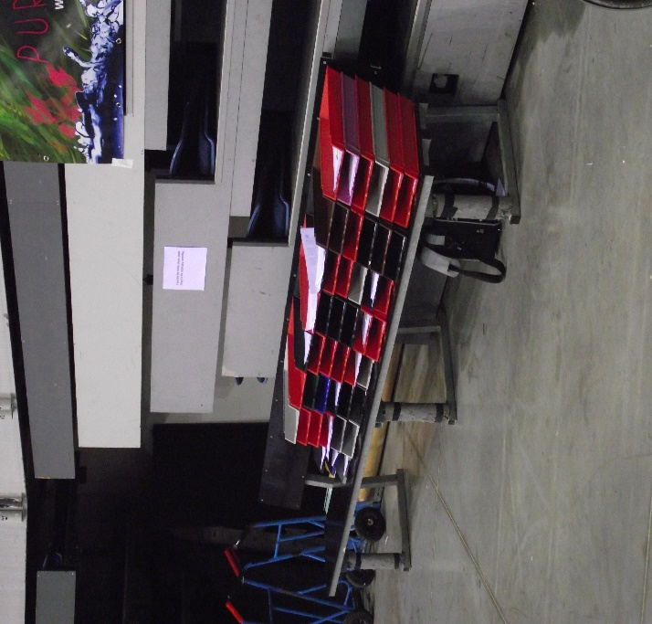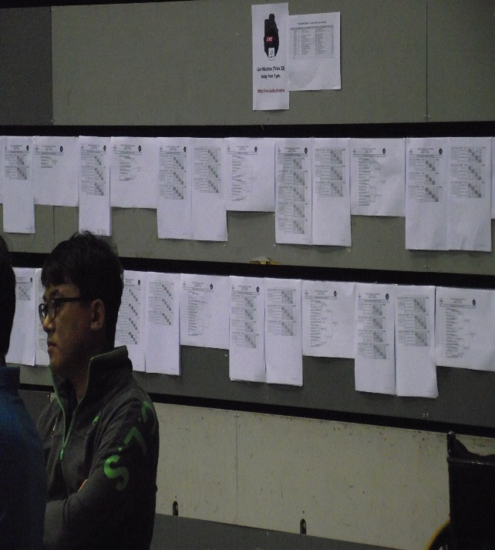

The pigeon-hales and the running results on the inform desk on the wall.

Medical service: During the tournament were present in the playing hall Dr. Juraj Stefak + one member of Slovak Red Cross was present with him in the playing hall too. Very near the Venue was big hospital and OC had the settlement with them about the
instantaneous availability for the ambulance car. During the whole tournament Dr..
Stefak had to treat minor disorders. The report about them gave to Referee and TD.
The medical service was organized very well and always immediately after the
notification that is needs some medical help

Service for media: Pavel Bilik from OC cooperated with the professional photographer Roman
Benicky, which prepared pictures for the web of ITTF, ITTF PTT and
Slovak Open web too and for the daily presentation of photos on 5 big screens on the long wall of dining room in the hotel Hilton and of course for the CD with the Results too.
He was sending some photos to newspaper too. I am sure, the Media serve on Slovak Open was excellent, therefore Roman Benicky is really very good and authentic photographer and his cooperation with Pavel Bilik was perfect!

Ceremonies: The tournament started without the Opening ceremony.
The Medals ceremony of the Single in classes was held in the break between the end of the singles and the start of team event in the time. Some of the medallist’s therefore weren’t present there. The Medals ceremony of the Team events was very good.
The Farewell Party in the hotel Hilton was really excellent with speeches from invited guests. After them was the commemorative presentations.

Evaluation:
Accommodation – The hotel Hilton and the hotel Lindner provided really good level of
accommodation and of them were near the Venue. It was very good for
the participants and for the organization of the tournament too

Transport - The transports from the both of Airports to hotel and the local
transport between the hotel Lindner and venue were the whole
time without any problems

Referee + Deputy Referee: Elio Corrado (ITA) and Katja Brand (SUI) worked the whole
tournament well. The whole time schedule were good and the
tournament every day finished in time although some . guidance was required in unusual situations

Call area
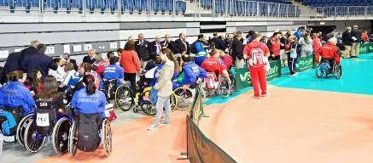
Call area, before a round of Team Event
Information: | Time schedule and draw were on the information board , all of the next information were given to the delegations through their pigeonholes.

Ball boys : They worked during the whole tournament not only as ball boys/girls,
but as the volunteers too. All of their work was really very good and
helped Organizing Committee with the organization

Service for wheelchairs: Directly in the big playing hall was the emergency service for
some actually needed wheelchair repairs. This service was opened for a period of the whole tournament and worked immensely.

The Palma Slovak Open Fa 40 tournament is a very good tournament, with very good organization,
and a big playing hall. Top level of the accommodation in hotels which are not very near from the
Venue.

I would like to congratulate to all of the members of the local O C, and their volunteers on a very good tournament put on in a very friendly and professional way. I also give thanks to the participants too, who without their co-operation we would not be able to get through the tournament. I would also like to thank my deputy, Francesco Nuzzo (ITA) for his help and guidance throughout the event.

Jim Kenny (ENG)
TD of Slovak Open 2015

